**CMR Institute of Technology**

**Kandlakoya Village, Medchal Rd, Hyderabad, Telangana 501401**

**Institute Innovation cell**

**Team Name:**

**Members:**

**1.Karnati Mahidhar**

**2.Gollena Vinay**

**3.Galipelly Vaishnavi**

**4.Srija Dulam**

**5.Kalluru Kavya Reddy**

**6.G.Naresh Kumar** ­­­­­

Idea Title: ARDUINO RADAR FOR OBJECT DETECTION

Problem Statement:

Accidents majorly occured at night and at early mornings due to fog and pollution ,since they cause reduced visibility ,the chances of an accident occuring is much higher.

# OVERVIEW

**In this project, we are going to design an Arduino radar project using Ultrasonic Sensor for detection. An** [**Arduino microcontroller**](https://robu.in/product-category/development-board/arduino/board/) **makes electronics more discipline.**

# GOALS/Objective

# To reduce the likelihood of much higher occurance of accident ,majorly due to fog.

# SPECIFICATIONS

In this project, we are going to design an Arduino radar project using Ultrasonic Sensor for detection. An [**Arduino microcontroller**](https://robu.in/product-category/development-board/arduino/board/) makes electronics more discipline.

This Arduino radar project aims to achieve a radar system prototype based on an Arduino board that detects stationary and moving objects. The radar system has different performance specifications, and it is also available in a variety of sizes.

# 

# MILESTONES

## Ideation/Data collection

Being safer is being responsible , “When safety is first,we last.” ,being safer is very important ,from the surveys and collected data major part of safety is destructed by accidents.Mostly accidents takes place at the early morning and nights . *The aim of this Arduino Radar project is to achieve a radar system prototype based on an Arduino board that detects stationary and moving objects.*

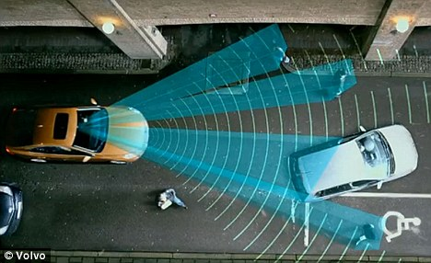

Fig 1: problem scenario

## Model Building

After uploading the code, the servo motors start running from 0 to 180 degrees and again back to 0 degrees. An ultrasonic sensor also rotates along with the servo as it is mounted on the motor. If an ultrasonic sensor detects any object within its range, you can see the same on the graphical representation.

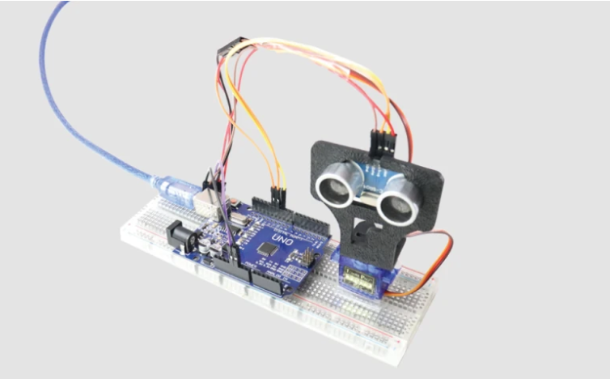 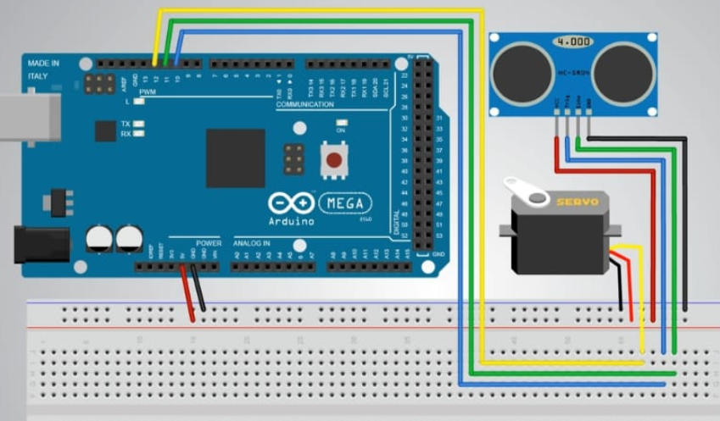

Fig 2 Model or blueprint: _____________________

## Components/Tools Understanding and usage

## **ULTRASONIC SENSOR**

An [**ultrasonic sensor**](https://robu.in/product/hc-sr04-ultrasonic-range-finder/) is a proximity sensor that is used to measure the distance of a target or object. It detects the object by transmitting ultrasonic waves and converts the reflected waves into an electrical signal. These sound waves travel faster than the speed of the sound that humans can hear.

For the calculation of the object distance, the sensor measures the time taken by the signal to travel between the transmission of the sound by the transmitter to the reflecting back towards the receiver.

The formula for this calculation is,

D = ½ T x C

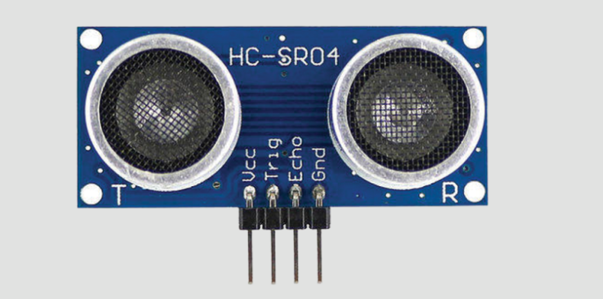

Fig 3.1: Component 1

## **Servo Motor:**

The [**servo motor**](https://robu.in/product/towerpro-sg90-9gm-1-2kg-180-degree-rotation-servo-motor-good-quality/) is a simple DC motor that can be controlled for specific angular rotation with the help of additional servomechanism. This motor will only rotate as much we want and then stop.

The servo motor is a closed-loop mechanism that uses positional feedback to control the speed and position. The servo motor is unlike a standard electric motor which starts and stops according to the power input. According to the signal, the servo motor will work.

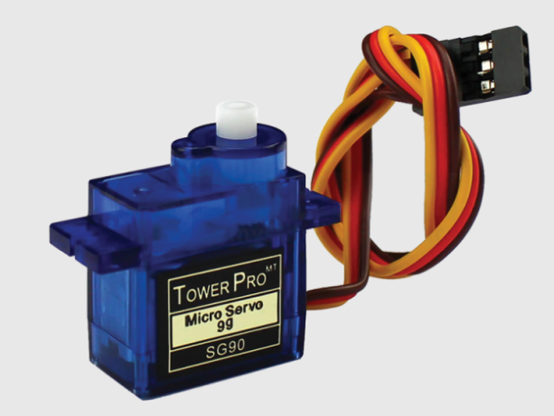

Fig 3.2 : Component 2

## **Preparing the Fixture:**

After making the connections, to build the fixture of this construction, we used a [**mounting bracket**](https://robu.in/product/easymech-snap-fit-abs-bracket-for-hc-sr04-ultrasonic-sensor/) as shown in the below image to fix the ultrasonic sensor.

After fixing it, the mounting bracket is screwed to the servo motor. Kindly use the DST (double-sided) tape to fix the servo motor firmly with the surface so that it can easily handle the weight of the bracket and the ultrasonic Sensor.

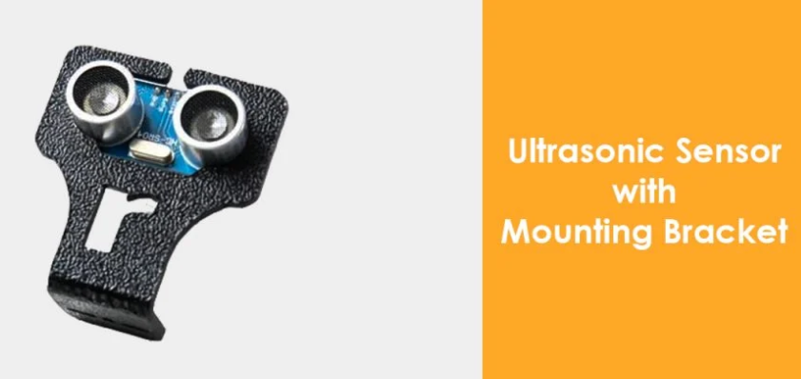 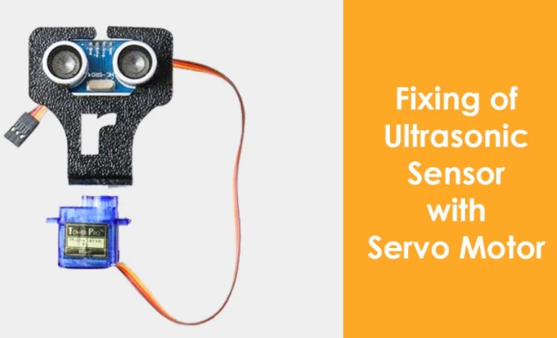

Fig 3.3: Component 3

### **Arduino:**

**The Arduino Uno is a type of Arduino board that is provided as an open-source board that uses an ATmega328p microcontroller in the board. The Arduino Uno contains a set of analog and digital pins that are input and output pins which are used to connect the board to other components. There are a total of fourteen I/O pins placed inboard in which six are analog input pins. The board has a USB connection that can be used to a power supply to the board. The board is used for electronics projects and used to design the circuit.**

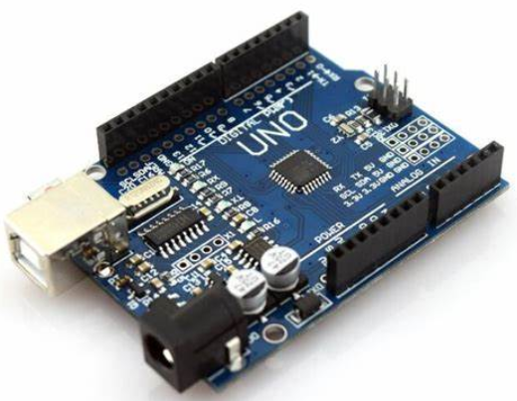 **FIG Arduino UNO**

## Prototyping

Lorem ipsum dolor sit Amet, constituter adipiscing elite, sed diam no Nummy nib euismod incident ut labret dolore magna aliquam era volitant

Fig 4 Prototype: _____________________

## Testing

## Fig 5 Testing/Users feedback

Lorem ipsum dolor sit amet, consectetuer adipiscing elit, sed diam nonummy nibh euismod tincidunt ut laoreet dolore magna aliquam erat volutpat